Final Project (100 points) Name Oliver Conover

For this project, you will be using six different databases from the book. So be careful to notice when you are changing to a different database. Each question is worth 2 points unless otherwise noted.

General Questions – Please highlight your answers, so it’s easier for me to grade. Thanks.

1. Look at the query below to answer the following questions.

select *

from orders

where orderdate BETWEEN '2012-09-01' AND '2012-09-30'

1. Will orders with a date of Sept 1, 2012 be included in my result set?

Yes

1. Will orders with a date of Sept 30, 2012 be included in my result set?

Yes

2. When you type a numeric value does it have to be in quotes? Like the Order number in this query.

Select *  
 From Orders  
 Where OrderNumber = ‘93820’

YES

NO

3. When linking tables, you should only use fields that are the Primary Key, Composite Primary Key or Foreign Key?

True

False

4. To perform a UNION, the two result sets must meet certain requirements. The first criteria is that the two queries must use the same

a. tables

b. number of tables

c. number of fields in the Select statement

d. number of JOINS in the Where statement

5. UNION ALL includes duplicate rows in the result set.

True

False

6. For the result set of a UNION query, what column names appear in the result set?

a. Column names from the first select statement in the UNION

b. Column names from the second select statement in the UNION

7. What command do you include with your COUNT command to eliminate duplicates?

a. ONCE

b. DISTINCT

c. UNIQUE

8. Tables and the number of rows in each table:

Bowlers 32

Bowler_Scores 1344

Match_Games 168

Teams 10

If I write a query with the Bowlers table and Teams tables, what is the largest number of rows that I can have in my result set?

32

9. When you write a query, what comes first the ORDER BY or GROUP BY?

a. ORDER BY

b. GROUP BY

10. Do I need the word ‘as’ before the alias OrderCount?

Select Customerid, count(*) as OrderCount

From SalesOrderHeader

Group by CustomerID

YES

NO

Use the **SalesOrderExample** database for the following questions.

11. Display the number of orders placed on each orderdate. 181 rows.

a. Paste your query here.

select o.OrderDate, count(o.OrderNumber) OrdersPlaced

from Orders o

group by o.OrderDate

12. Display the orders placed in December 2012. 143 rows

a. Paste your query here.

select o.OrderDate, count(o.OrderNumber) OrdersPlaced

from Orders o

where o.OrderDate between '2012-12-01' and '2012-12-31'

group by o.OrderDate

b. Think of another way that you could request December 2012 by changing your WHERE Statement. Paste your query here.

select o.OrderDate, count(o.OrderNumber) OrdersPlaced

from Orders o

where o.OrderDate >= '2012-12-01' and o.OrderDate <= '2012-12-31'

group by o.OrderDate

13. Show the Ship Date as 11 characters using the CAST function shown on page 124. 944 rows

a. Paste your query here.

select cast(o.ShipDate as varchar(11)) VarCharDate

from Orders o

14. Show the Order Number and Subtract the OrderDate from the ShipDate to calculate the Days it takes to ship an order. Use the Alias DaysToShip for the calculated field. Page 131. Use the Cast AS INTEGER function, to make the number a single digit number. Sequence the result set so the largest DaysToShip are listed first. 944 rows. (4 points)

a. Paste your query here.

select o.OrderNumber, cast((o.ShipDate - o.OrderDate) as int) DaysToShip

from Orders o

15. Show how many customers are in each state. 4 rows

select c.CustState, count(c.CustomerID) CustomerCount

from Customers c

group by c.CustState

16. Show the product number and name and its **lowest** retail price. 40 rows

a. Paste your query here.

select ProductNumber, ProductName, min(RetailPrice) LowestPrice

from Products

group by ProductNumber, ProductName

17. Show an alphabetized list of products with a retail price of $99 or more. 13 rows

a. Paste your query here.

select ProductNumber, ProductName, min(RetailPrice) LowestPrice

from Products

where RetailPrice > 99

group by ProductNumber, ProductName

order by ProductName

18. Show the order numbers that are for 5 or more product. First write a query that shows the order number and counts the number of products. Use a HAVING so the query only shows a count greater than 5. (4 points) 304 rows

a. Paste your query here.

select OrderNumber, count(ProductNumber) ProductCounts

from Order_Details od

group by OrderNumber

having count(ProductNumber) > 5

Use the **BowlingLeagueExample** database for the following questions.

19. Show the bowler names and their rawscore with the **highest** scores listed first. 1344 rows

a. Paste your query here.

select b.BowlerLastName + ' ' + b.BowlerFirstName BowlerName, bs.RawScore

from Bowlers b

join Bowler_Scores bs

on bs.BowlerID = b.BowlerID

order by bs.RawScore desc

b. Revise that query and use the TOP command to show only 3 bowlers with highest scores. Page 96. Paste your query here. 3 rows.

select TOP 3 b.BowlerLastName + ' ' + b.BowlerFirstName BowlerName, bs.RawScore

from Bowlers b

join Bowler_Scores bs

on bs.BowlerID = b.BowlerID

order by bs.RawScore desc

20. Show the bowler names and their rawscore if they won the game. Hint: WonGame field is 1 if they won. 695 rows

a. Paste your query here.

select b.BowlerLastName + ' ' + b.BowlerFirstName BowlerName, bs.RawScore

from Bowlers b

join Bowler_Scores bs

on bs.BowlerID = b.BowlerID

where bs.WonGame = 1

order by bs.RawScore desc

21. Show the bowler names that have a Middle Initial in our database. 11 rows. Your result set should look like this:

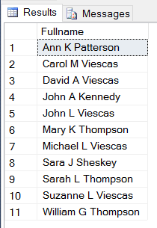

Notice the first, middle and last name are in one column called FullName

a. Paste your query here.

select b.BowlerFirstName + ' ' + b.BowlerMiddleInit + ' ' + b.BowlerLastName FullName

from Bowlers b

where b.BowlerMiddleInit is not null

order by b.BowlerFirstName

22. Show the bowlers and their lowest rawscore. Sequence from lowest to highest. Paste your query here. 32 rows

select b.BowlerFirstName + ' ' + b.BowlerLastName FullName, min(bs.RawScore) LowestScore

from Bowlers b

join Bowler_Scores bs

on bs.BowlerID = b.BowlerID

group by b.BowlerFirstName, b.BowlerLastName

order by LowestScore

23. Display for each bowler the bowler name and the average of the bowler’s raw game scores for bowlers whose average is greater than 155. Hint: You need a simple HAVING clause comparing the AVG to 155. (4 points)

select b.BowlerFirstName + ' ' + b.BowlerLastName FullName, avg(bs.RawScore) AverageScore

from Bowlers b

join Bowler_Scores bs

on bs.BowlerID = b.BowlerID

group by b.BowlerFirstName, b.BowlerLastName

having avg(bs.RawScore) > 155

order by AverageScore

Use the **SchoolSchedulingExample** database for the following questions.

24. Show the staff name and calculate their monthly salary by dividing the Salary by 12 and call it MonthlySalary. Paste your query here. 27 rows (4 points)

select StfLastname + ' ' + StfFirstName StaffName, Salary / 12 MonthlySalary

from Staff

25. Send your output from the last query to an excel file, clean up the file and upload it with your answer sheet. Call the file your lastname and final. When you’re done, make sure it opens in excel. (5 points)

26. Create a mailing list for students and staff, sort by Zip code. 45 rows (4 points)

Use alias for your fields, so the titles of each column match the example below.

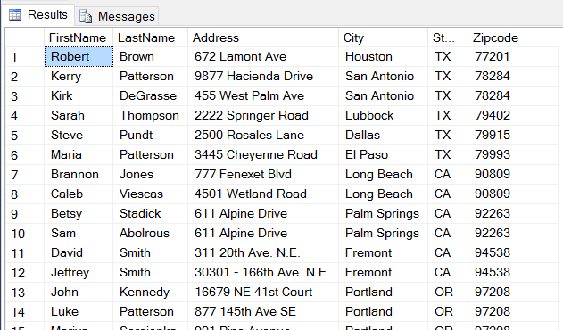

a. Paste your query here.

select s.StfFirstName FirstName, s.StfLastname LastName, s.StfStreetAddress Address, s.StfCity City, s.StfState State, s.StfZipCode Zip

from Staff s

UNION

select st.StudFirstName, st.StudLastName, st.StudStreetAddress, st.StudCity, st.StudState, st.StudZipCode

from Students st

order by s.StfZipCode

27. For the staff, show each subject and category that they teach. Use **four** tables including one linking table, to generate the following result set. Shown are only the first few rows. Use the column headings to identify the fields and tables that you will need to use. 110 rows (8 points)

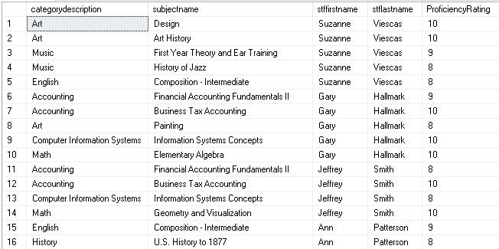

a. Paste your query here.

select c.CategoryDescription, sb.SubjectName, s.StfFirstName, s.StfLastname, fs.ProficiencyRating

from Categories c

join Subjects sb

on sb.CategoryID = c.CategoryID

join Faculty_Subjects fs

on fs.SubjectID = sb.SubjectID

join Staff s

on s.StaffID = fs.StaffID

Use the **RecipesExample** database for the following questions.

28. List all the recipes that are main course and that have notes. 4 rows. Paste your query here.

select *

from Recipes r

join Recipe_Classes rc

on rc.RecipeClassID = r.RecipeClassID

where rc.RecipeClassID = 1

and r.Notes is not null

29. If you wanted to cook every recipe that is in the database, how much of each ingredient would you use? This query uses three tables. 65 rows. Order by Ingredientsname, show the measurement description and sum the amounts. The first rows of your result set should look like: (8 points)

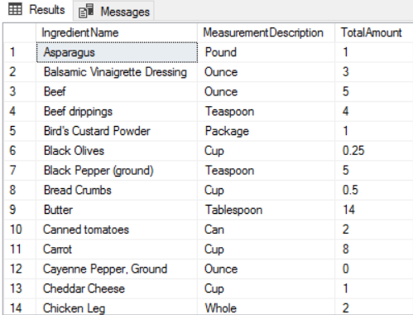

1. Paste your query here.

select i.IngredientName, m.MeasurementDescription, sum(ri.Amount) TotalAmount

from Recipe_Ingredients ri

join Ingredients i

on ri.IngredientID = i.IngredientID

join Measurements m

on m.MeasureAmountID = ri.MeasureAmountID

group by i.IngredientName, m.MeasurementDescription

order by i.IngredientName

Use the **EntertainmentAgencyExample** database for the following questions.

30. List the customer names that have attended an engagement that start and end on the same day. Only list the customer name once. 4 rows.

a. Paste your query here.

select distinct c.CustFirstName + ' ' + c.CustLastName CusomtersSameDayEngagements

from Customers c

join Engagements e

on e.CustomerID = c.CustomerID

where e.StartDate = e.EndDate

31. List the agent with no bookings. Books are in the Engagements table. 1 row

a. Paste your query here.

select a.AgtFirstName, a.AgtLastName

from Agents a

left join Engagements e

on e.AgentID = a.AgentID

where e.AgentID is null

32. Produce a list of customer last names who like contemporary music together with a list of entertainers Stagenames who play contemporary music. You will want to use a UNION, so both queries are in one result set. 5 rows. Chapter 10.

a. Paste your query here.

select c.CustLastName ContemporaryFans

from Customers c

join Musical_Preferences mp

on mp.CustomerID = c.CustomerID

join Musical_Styles ms

on ms.StyleID = mp.StyleID

where ms.StyleID = 10

UNION

select e.EntStageName

from Entertainers e

join Entertainer_Styles es

on es.EntertainerID = e.EntertainerID

join Musical_Styles ms

on ms.StyleID = es.StyleID

where ms.StyleID = 10

33. What is the average salary of all our booking agents? 1 row Paste your query here.

a. Paste your query here.

select avg(a.Salary) AverageAgentSalary

from Agents a

Use the **BowlingLeagueModify** database for the following questions.

34. Change the name of the ‘Huckleberrys’ bowling team to the ‘SQL Rocks’. 1 row updated. Display all fields in the table to see that the record updated. (3 points)

a. Paste your query here.

UPDATE Teams

SET TeamName = 'SQL Rocks'

WHERE TeamID = 9

35. Change the zipcode to 98999 for those bowlers living in Redmond. 7 rows. (3 points)

a. Paste your query here.

UPDATE Bowlers

SET BowlerZip = 98999

WHERE BowlerCity like 'Redmond%'

36. Insert a new record in the teams table with a teamid of 11 and the team name of ‘Final Project Done’. 1 row. (3 points)

a. Paste your query here.

SET IDENTITY_INSERT Teams ON

INSERT INTO Teams

(TeamID, TeamName)

VALUES

(11, 'Final Project Done')

I wish you the best as you continue your education. Katrina Bivona

You rock as a professor! Have a wonderful Winter Break! 😊

-Oliver C.